Step 1 : Install MinGW

Step 2 : Install VS Code

Step 3 : Connect C/C++ and VS Code

Step 4 : Run a C/C++ program on VS Code

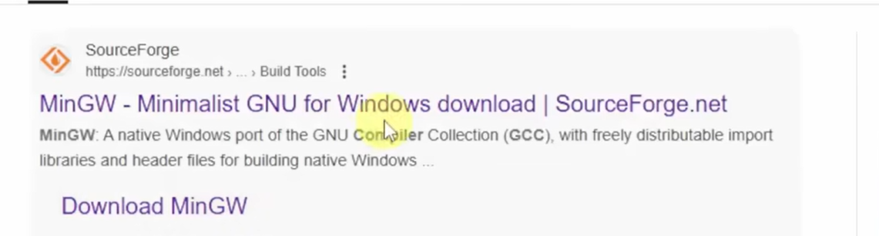

Open google 🡪mingw compiler 🡪 sourceForge (MinGW – Minimalist GNU for Windows) 🡪 Click the download button

Install 🡪 Continue 🡪 Continue 🡪

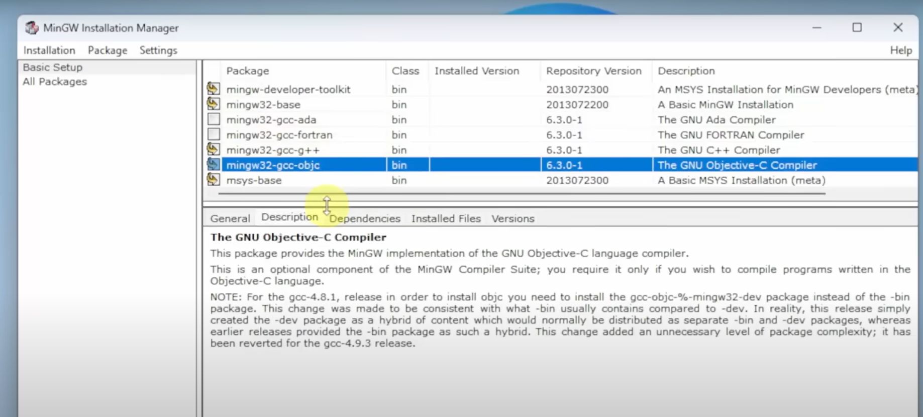

Go to installation && click apply changes 🡪 Apply 🡪 Click close

Go to location 🡪 Home Page 🡪 This PC 🡪 c drive 🡪 MinGW 🡪 go to bin 🡪 right click && copy the path

Go to start 🡪 type environment variables 🡪 click open on “edit the system env variables” 🡪 click env variables 🡪 inside system variable section click path && double click 🡪 click new 🡪 right click && paste the copied path 🡪 click ok 🡪 ok 🡪 ok

Verification :-

Cmd 🡪 click open 🡪 g++ --version press enter

Installation of vs code on windows 11

Google🡪 vs code

